Lesson 7 – AI Builder and SAP



Exercise 16: Create An AI Builder Model 2
Exercise 17: Create Vendor Invoice Using AI Builder 16

Exercise 16: Create An AI Builder Model
In the next exercise, we will create and train an AI Builder model to capture information from our vendor invoices so we can have them automatically created in SAP.

- Browse to https://make.powerautomate.com and confirm you are still signed in with the credentials supplied by the instructor and you are in the correct environment.

- On the left-hand side, expand the AI Builder section and click on + New AI Model.

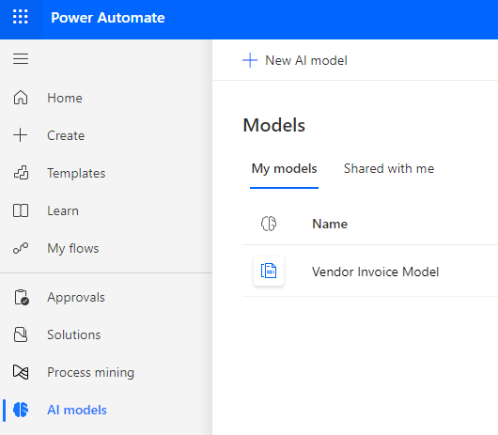

- Select the Extract custom information from documents.

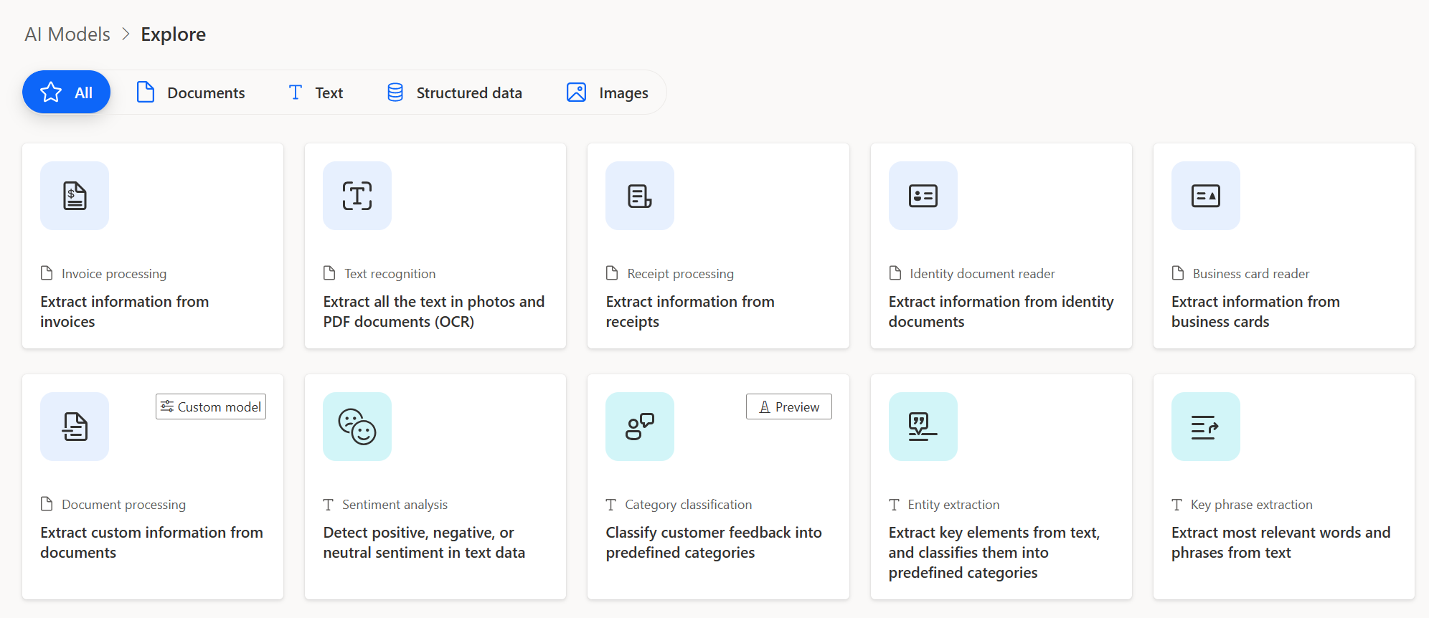

- Click on Create Custom Model in the bottom right-hand corner. 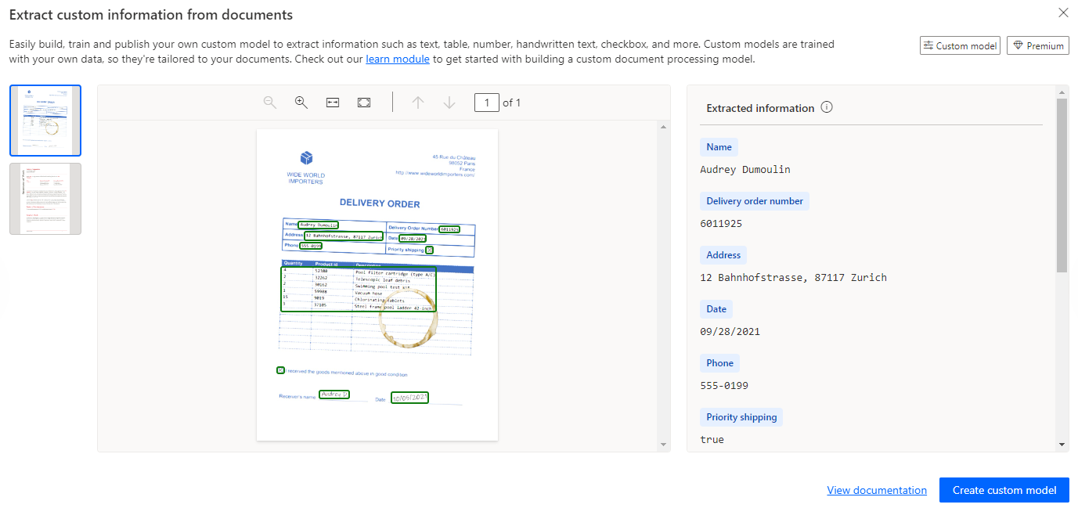
- Rename the model. In the upper right-hand corner click on the pencil icon to rename the model. Rename the model Vendor Invoice Model-XX where XX are your initials. Click on Rename.

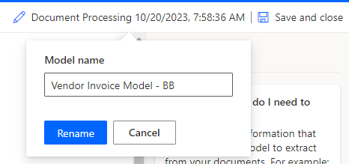

- Select Invoices (preview) for the document type and then click Next.

. 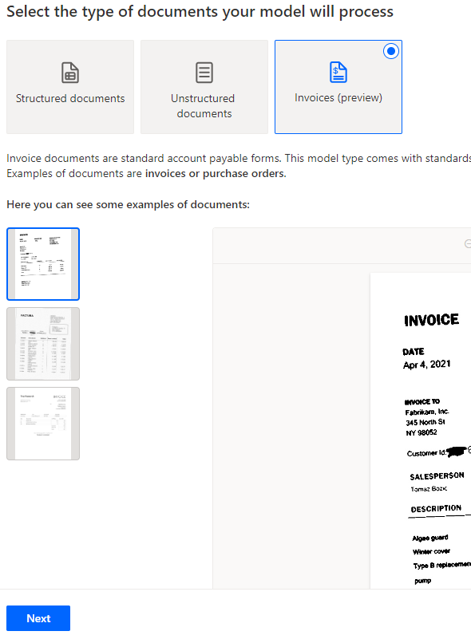

- Add the Fields for Extraction. The invoice model has all the fields we need for our vendor invoice, but we will add a new line item table so we can collect the line item number. Click on the drop-down menu in the + Add box and select Table.
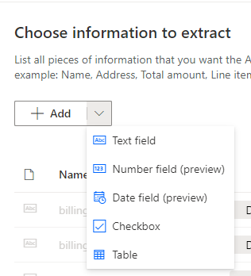

- Type Line Items as the Name for the table and click on Column 1 and select Edit column.

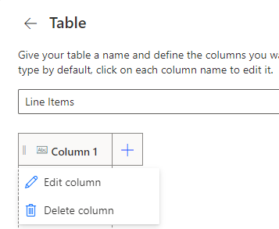

- Change the Name to Line Item and Type to Number with Format as dot (.) for decimal separator and then click on Confirm.
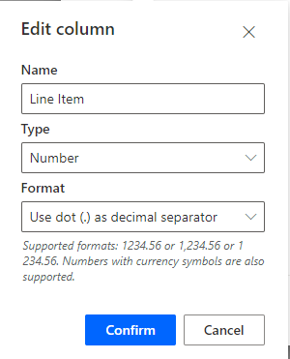

- Click on the plus sign to add more columns based on the information in the table below and then click on Done.

Name | Type | Format
Description | Text
Quantity | Number | Use dot (.) as decimal separator
Unit | Text
Unit Price | Number | Use dot (.) as decimal separator
Total Price | Number | Use dot (.) as decimal separator

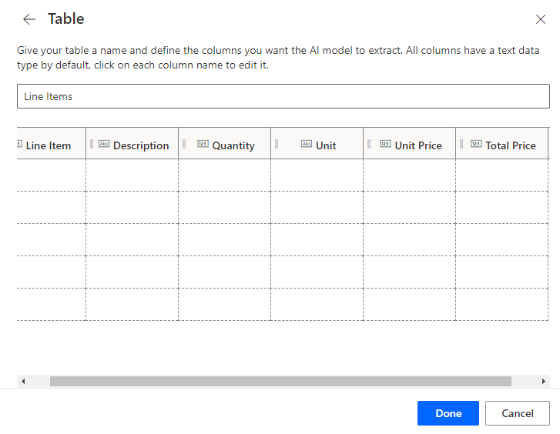
- Click on Next.
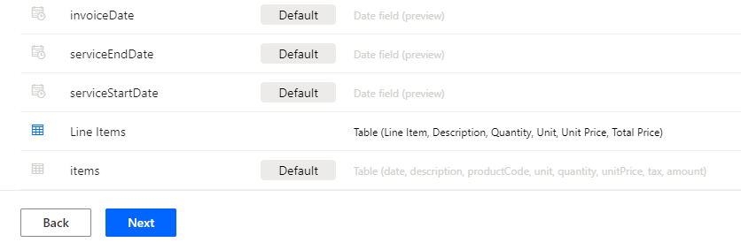
- Train the model. We are now ready to train the mode with some sample invoices. Click on New collection and then the + in Collection 1.
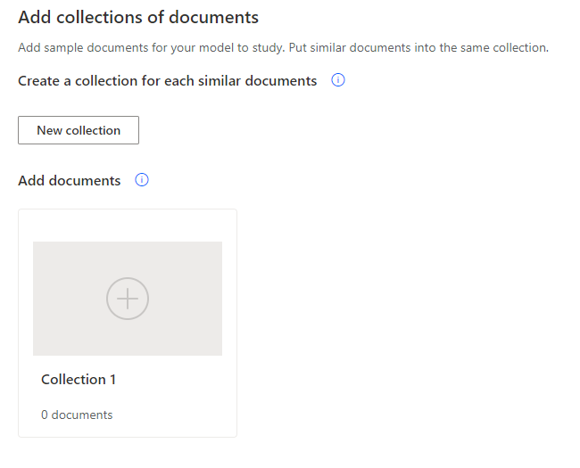
- Click on Add documents.
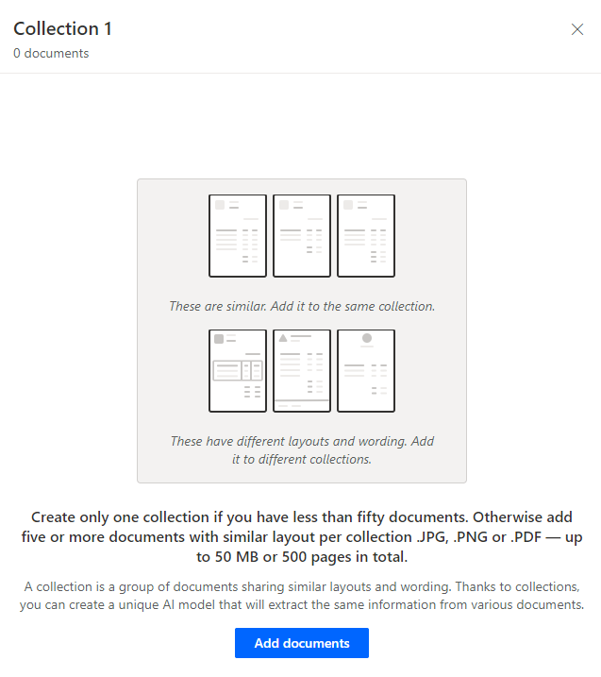

- Select the source for your documents. Click on My device and browse to where you downloaded the documents at the beginning of the workshop.

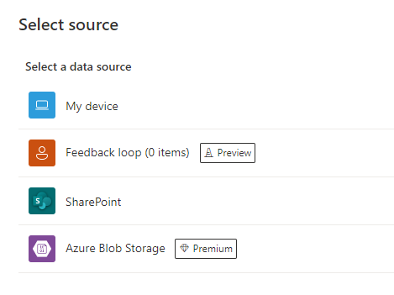

- Select all 5 Vendor Invoices from the Train folder.
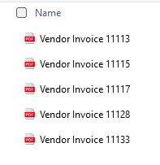
- Click on Upload 5 documents and then click on Done.

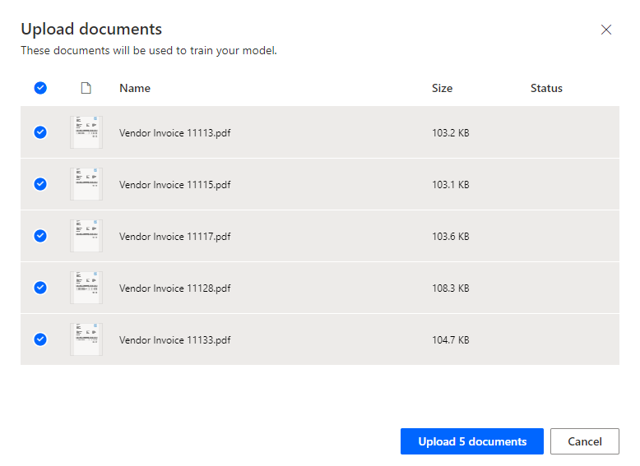

- Click on Next.

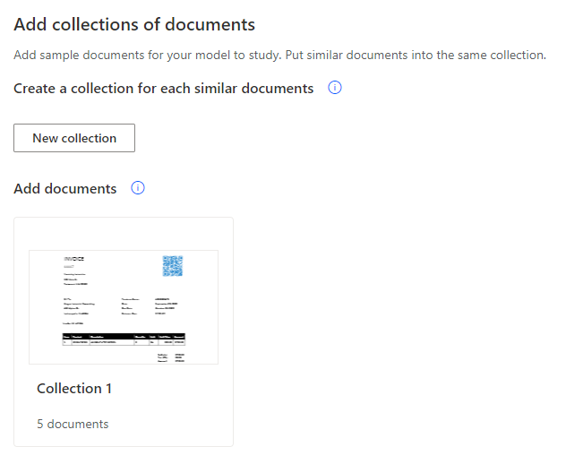
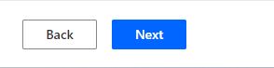
- Tag the Documents. Next, we will tag the areas on the invoice and associate them with our fields. The first document has been selected. You can see all the default fields have been selected and mapped. On the right-hand side under the text fields, you can hover over purchaseOrder. You will see on the invoice which field has been mapped.

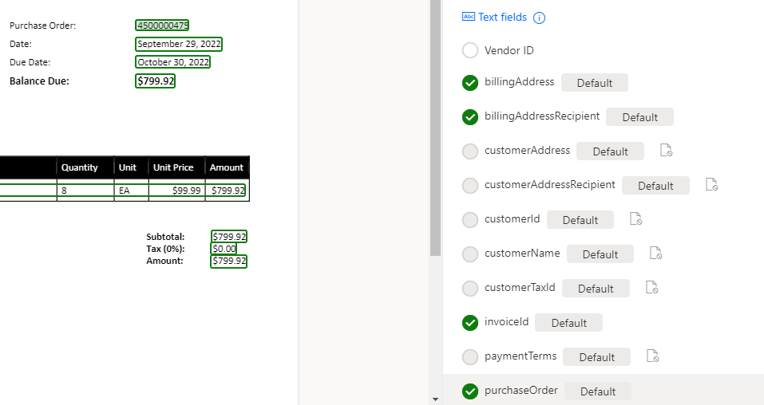

- Remove the items tag from the Line Items table. Select the blue icon for the items table on the invoice and then select Remove Tag.

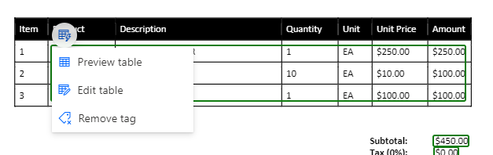
- Confirm you want to remove the tag. Click on Remove.

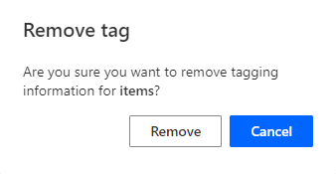
- Re-select the Line Items table using your cursor and select the Line Items table.

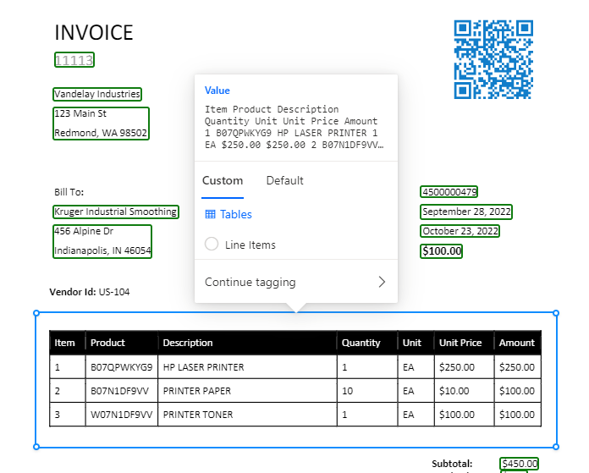
- We can now map the Line Items table. There are blue pop-ups with guidance on how to tag the table. When you mouse over the table, your cursor will turn to a plus sign with a blue horizontal line. Click to create lines separating the header and the 3 line items.
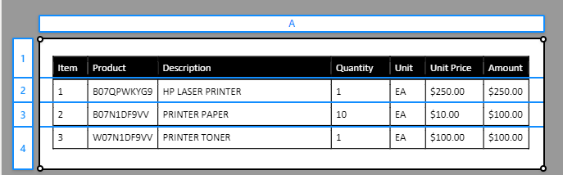

- Map the columns. Hold down the Crtl key and click to change the mapping to a vertical line and map out the columns.
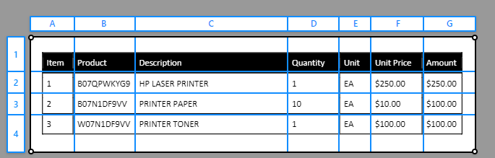

- Label the columns. Click on the letters for the columns and map to the correct field.
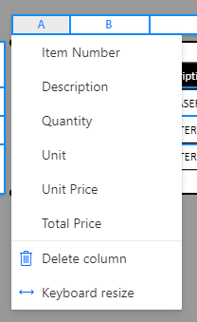
A – Item Number
B – Not mapped
C – Description
D – Quantity
E – Unit
F – Unit Price
G – Total Price

- Turn on the Ignore first row to remove the header line. On the right-hand side, toggle on the Ignore first row and confirm the table is mapped properly and click on Done.

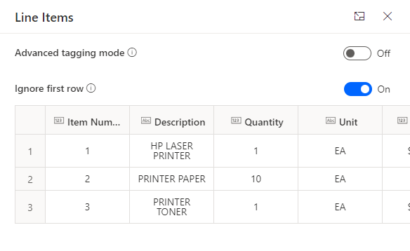
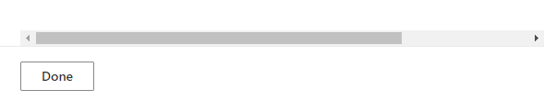

If you can’t get the last document to save. On the right-hand side, select ellipse (…) of the items table and remove from document.

- Repeat the same steps for mapping the Line Item table for the remaining 4 documents and then click Next. The model should automatically map the column names after you complete the first invoice, so you only need to map the rows and turn on the Ignore First Row.

- Train the model. We are now ready to train the model. Click on Train. It may take a few minutes to finish training.
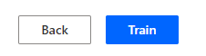

- Test your model. When the model is finished training, you can see the results of accuracy with more details on the specific items we are extracting. We are now ready to Publish the Model. Click on Publish.

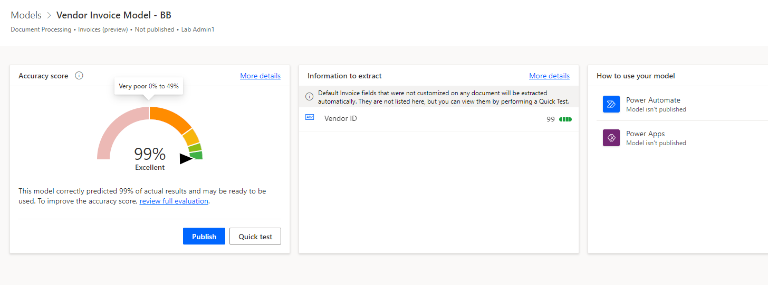

- Add AI Builder Model to our solution. Click on Solutions, select the SAP Procurement Approval and AI Builder Flows solution, click on the ellipse (…) and click on Edit.

The next steps will update the cloud flow to use the AI Model you just built and update the dynamic content to pull from this new model. If you did not finish your AI Builder model or don’t want to update the flow, you can skip the rest of this exercise and move onto the next one.

- Edit the cloud flow. Select the CreateVendorInvoiceFromEmail cloud flow, click on the ellipse (…) and then Edit and Edit in new tab.

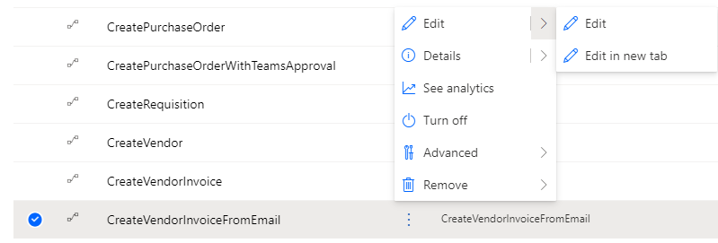

Overview of Cloud Flow. This flow is triggered when an email arrives in the Inbox. We use variables to capture information about each invoice that comes from the data extracted with our AI Builder Model. In the interest of time, we will update only certain parts of this flow.

- Expand the Apply to each ATTACHMENT action. Expand the Extract Information from documents action. Add your new AI Model. In the AI Model field, select the Vendor Invoice Model-XX you just created.

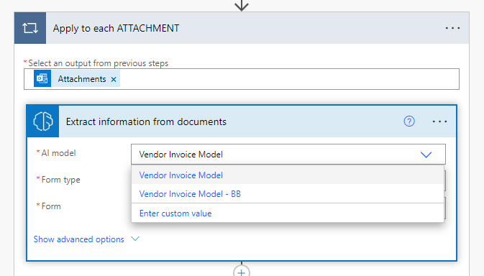

- Expand the Set Header Action. Update the schema in the Value section to pull data from our AI model. In the Order name/value pair, remove the existing dynamic content and insert purchaseOrder value from Dynamic Content. In the Total Price name/value pair, insert invoiceTotal value from Dynamic Content.

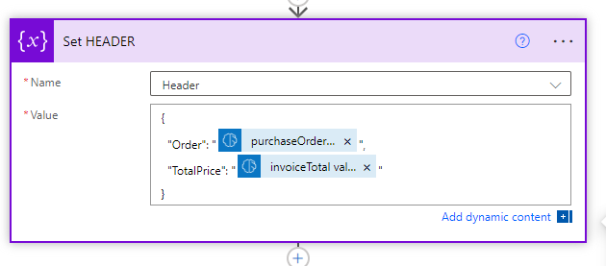

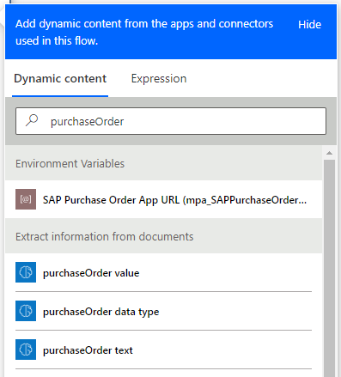

- Expand the Apply to each item action and then expand the Append to ExtractedItems action. We will update the name/value pair the same way as the step above. Using the table below, update values with the following Dynamic Content from the AI Model.

Name | Dynamic Content
Description | Line Items Description value
Quantity | Line Items Quantity value
Item | Line Items Line Item value
Unit | Line Items Unit Value
TotalPrice | Line Items Total Price Value

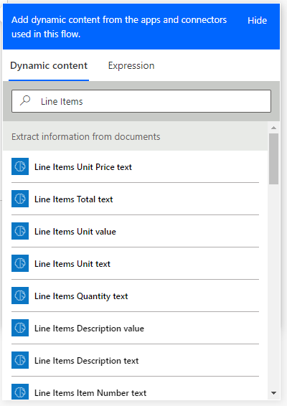
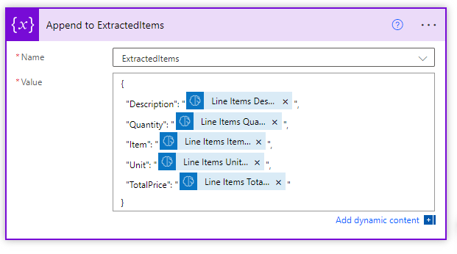

- Save the Cloud flow. Click on Save.

We have now finished updating the cloud flow that will use the AI Builder model to extract data from invoice that are received via email.

Exercise 17: Create Vendor Invoice Using AI Builder
We can now test our creation of the vendor invoice using the AI Builder Model. We will simulate the vendor sending us an email with the invoice as an attachment. This will kick off our cloud flow to run our AI Builder Model to pull the information from the invoice. This information is returned to SAP and a vendor invoice is created in SAP. We will then go back into our Power App and refresh the screen to see the vendor invoice number listed in our app.

- Retrieve the PO Number from Lesson 6, Exercise 15. Paste the PO number onto the Vendor Invoice Template in your Workshop Resources.
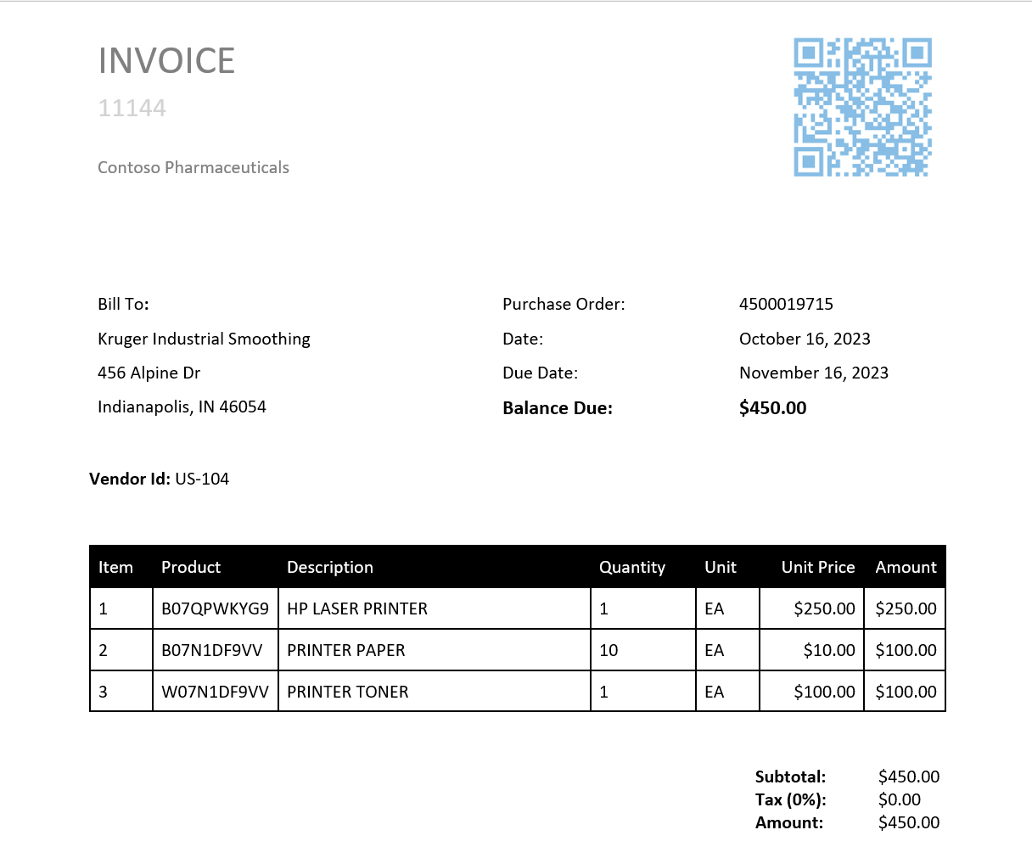
- Save as a PDF on your desktop so you can insert into an email. I usually add the PO number in place of the word Template.
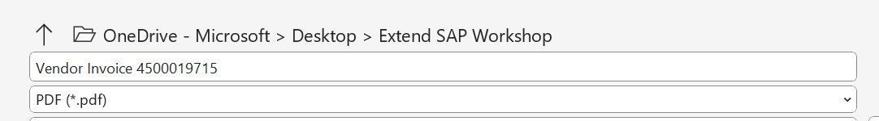

- Open the O365 portal to access Outlook. In the same browsers session, browse to https://www.office.com. Ensure you are still using the credentials supplied by the instructor. Click on Outlook.

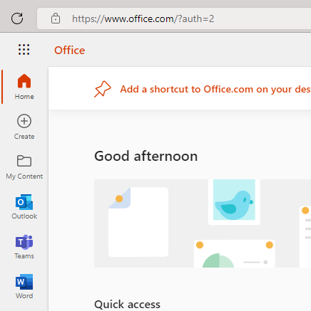
- Click on New Message.

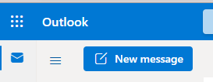

- Compose email message. Send the message to yourself using the credentials supplied by the instructor, fill out the subject line and attach the vendor invoice we created in the previous exercise. Click on Send.
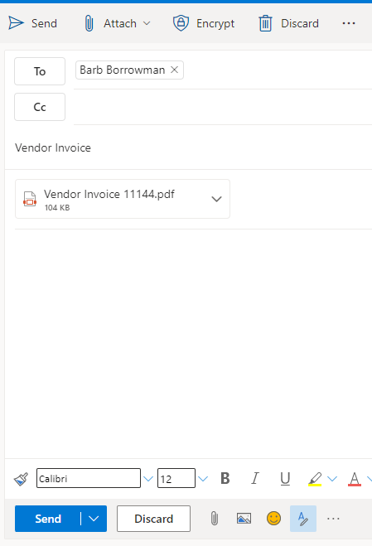

- Go back to the Power App. Click on the tab that has the Purchase Order canvas app open. Click on the Refresh button in the upper right-hand corner and you should now see the invoice as a hyperlink in the Items section.

